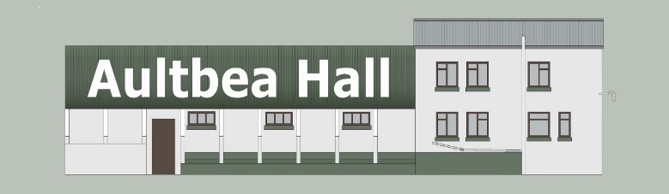

MEMBERSHIP APPLICATION FORM
Aultbea Hall [SCIO] SC051608

Aultbea Hall [SCIO], a registered charity, is now responsible for Aultbea Hall.
Membership is open to anyone aged 16 years or over who lives in the area served by Aultbea Community Council.
Our constitution and Data protection & privacy policy can be seen on the Hall website: www.aultbeahall.org.uk

Please support the Hall and its activities by becoming a member.
There is no fee, and annual renewal is not required. Membership ceases if you contact the Secretary to resign, and/or you no longer live in the area.

Full name

Postal address

Postcode
Email address (which will be our usual way of contacting you, unless you request otherwise)

Telephone
Signature

Date

Thank you!

